Using this guide
This guide accompanies the National Treasury’s Strategic Procurement Framework (SPF) for Strategic Sourcing in the Public Sector. For more information, visit the National Treasury website at http://ocpo.treasury.gov.za/

OPPORTUNITY ANALYSIS AND IDEAS GENERATION

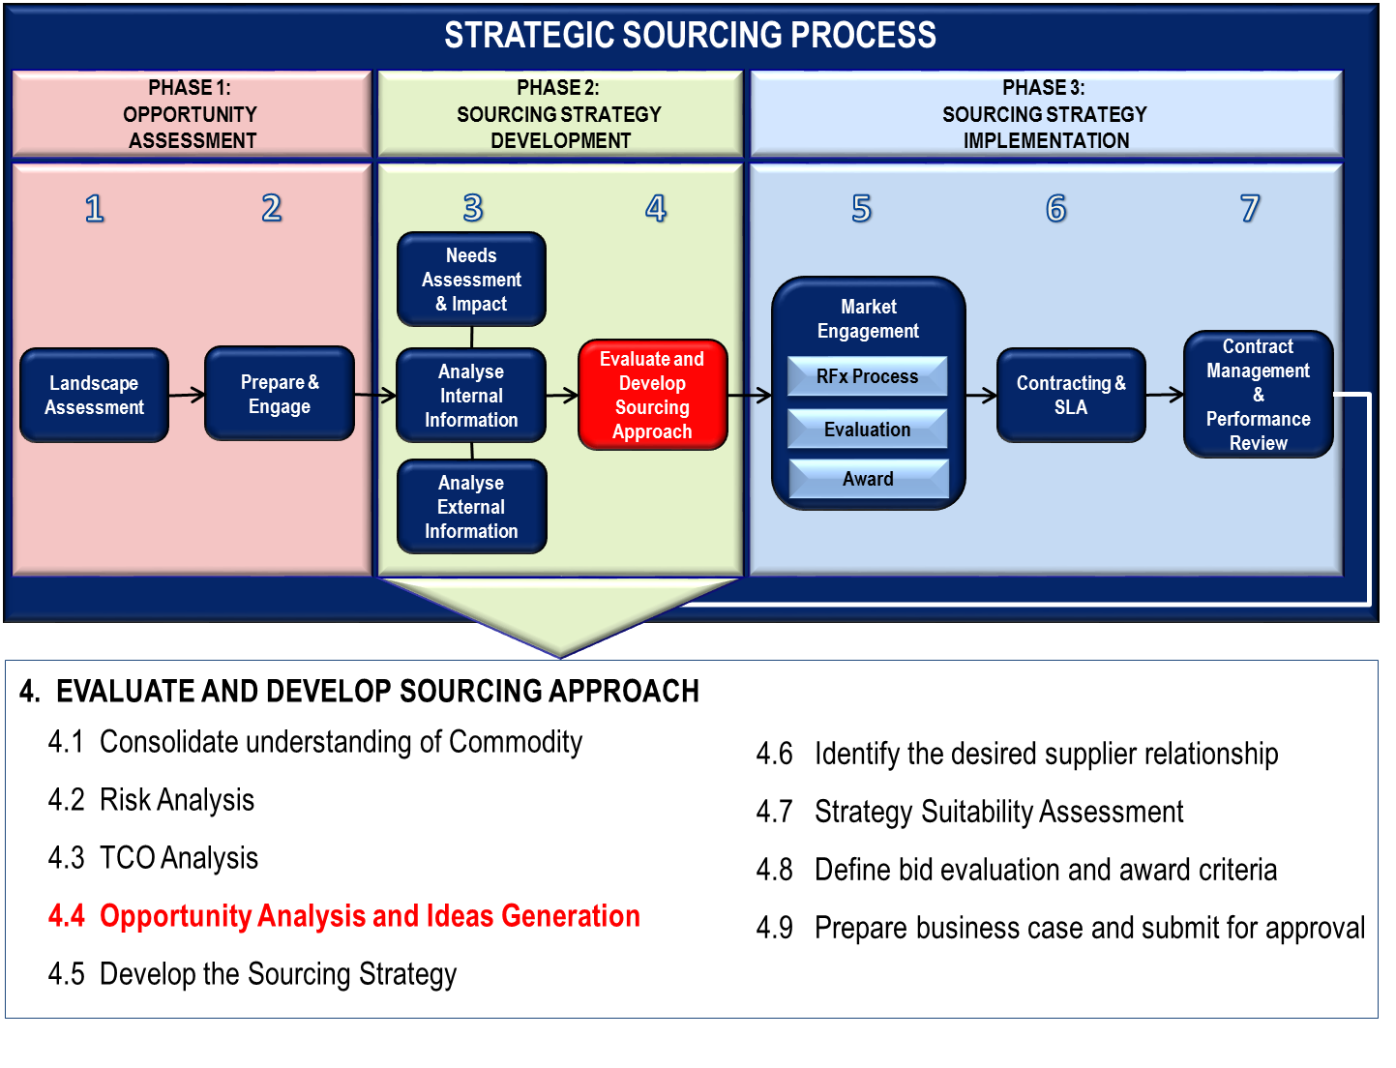
Opportunity Analysis and Ideas Generation are done during Stage 4 of the Sourcing Strategy Development phase as part of evaluating and developing the sourcing approach. The objective of this exercise is to identify all possible opportunities where money can be saved and where efficiency improvements can be made. During this stage you want to generate the ideas, group them according to themes, evaluate and quantify the ideas.

IDENTIFY OPPORTUNITIES
Cost benefits and value opportunities are identified throughout the project for the identified commodity. The different stages in the Project Plan have been developed to assist the team in the systematic identification and rationalisation of opportunities as they progress.
From the Spend and TCO analysis; the depth and possible approach to sourcing strategies becomes apparent, however:
- Beware of spending too much time trying to eliminate the last bit of uncertainty
- Be cautious of historical information – by its nature, it is backward looking and demand plans may change significantly depending on business strategy:
    - Volume changes through aggregation
    - Volume changes through product volume demand changes
    - New categories as a result of emerging technologies

GENERATE, GROUP, EVALUATE AND QUANTIFY IDEAS
All ideas/opportunities will be grouped, evaluated and assessed. One aspect that will be part of the sourcing process is the implementation of the opportunity, hence, the analysis of the value of the opportunity compared to the cost of implementing the opportunity will be play a crucial role.
Analyse the current Commodity group situation from multiple perspectives, before constructing an approach, or set of approaches, designed to optimise the Department’s position and deliver the final business case for approval.
The following diagram illustrates the process of generating ideas through brainstorming, grouping the ideas in similar themes, evaluating each idea and prioritising the ideas in terms of its value and ease of implementation.

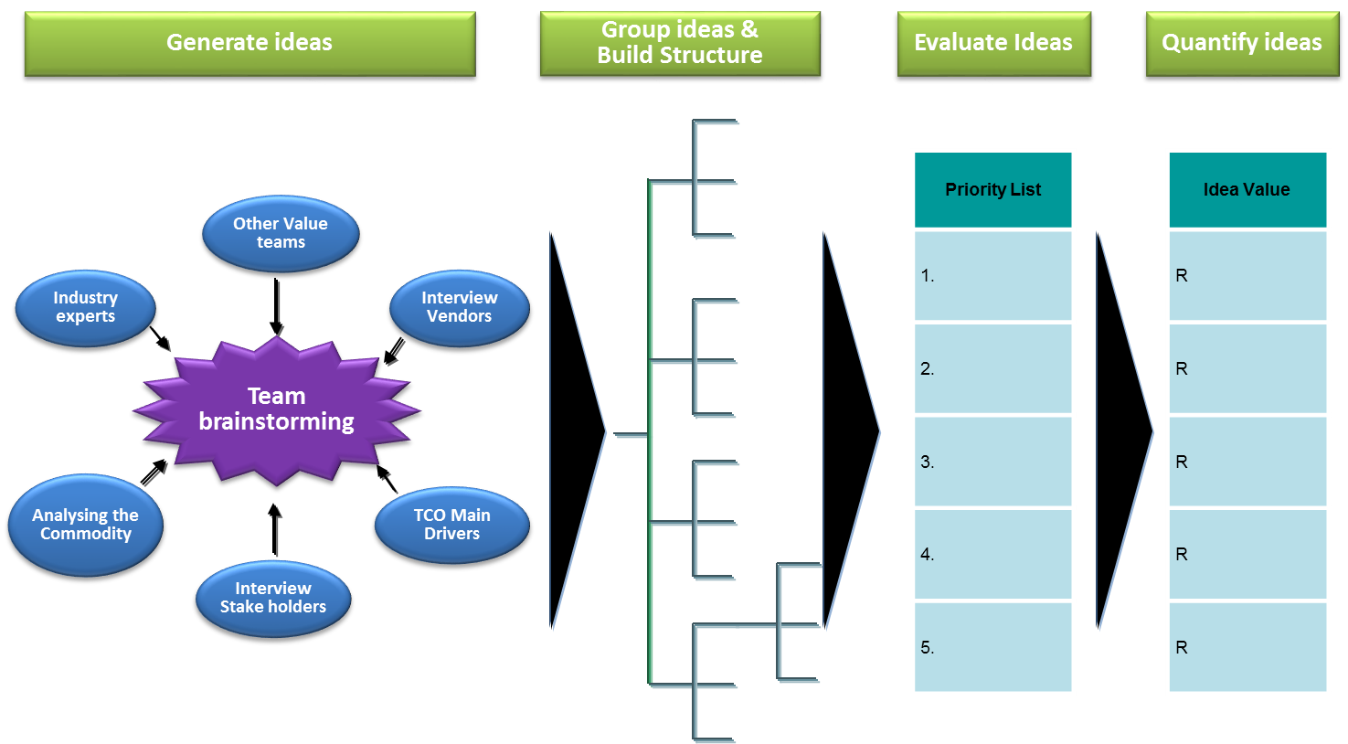

Generate ideas
The Sourcing Methodology and different stages in the Strategic Sourcing Process have been developed to assist the sourcing team in the systematic identification and rationalisation of value opportunities as they progress.
Idea generation and value identification already start during the investigation phase and are recorded as part of performance information, investigated and updated throughout the process in support of the final business case to be delivered. Final cost and value benefits are defined, validated and approved. It must be recorded, managed and tracked throughout the souring process.
It is the responsibility of the Cross Functional Sourcing Team (CFST) to identify opportunities relating to the identified commodity within the Supply Chain and Departments. The most effective way to identify all the possible opportunities is for the CFST to brainstorm the opportunities and list them, regardless whether they are good or bad ideas. See Annexure 1 for Brainstorming Session Tips.

Group ideas and Build a Structure
Various opportunities will become apparent as to where cost can be reduced, whether it be external, internal or in joint process improvement.

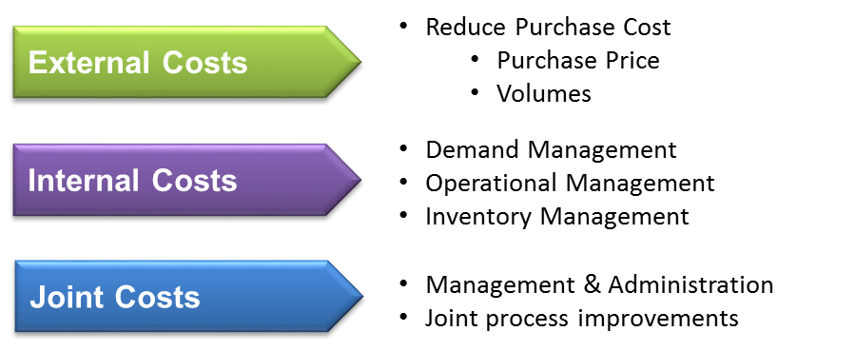

Options to reduce External Costs

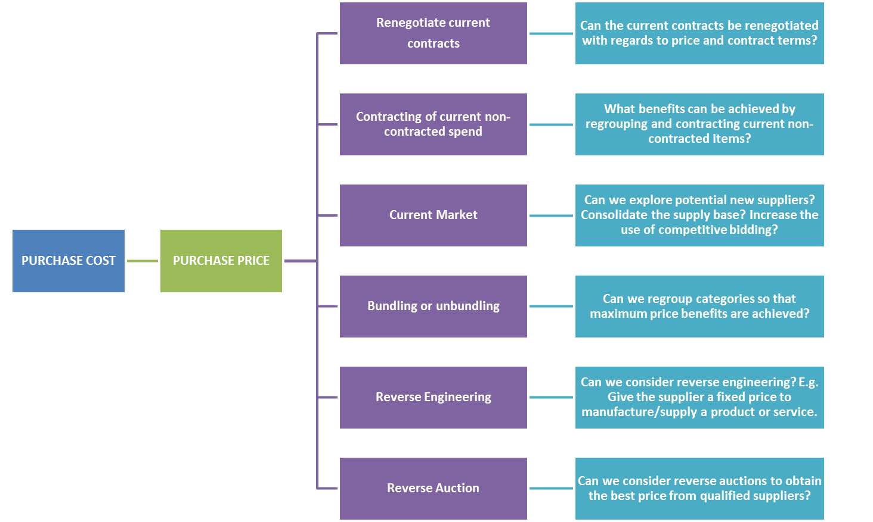
Continue…..
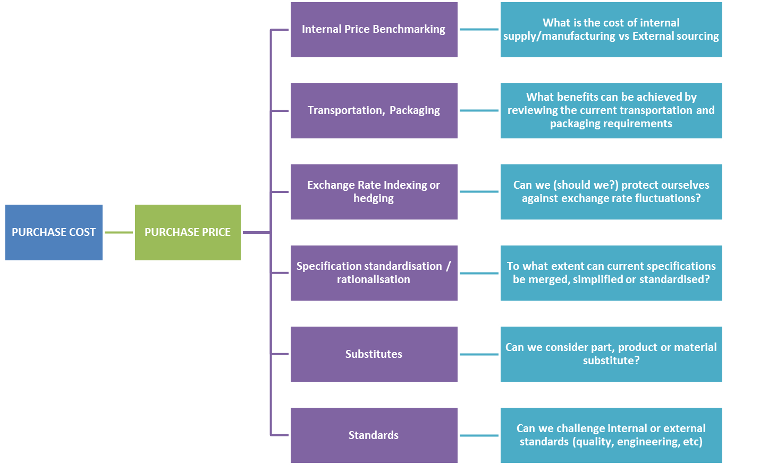
Continue…..
……continue

……continue

Options to reduce Internal Costs
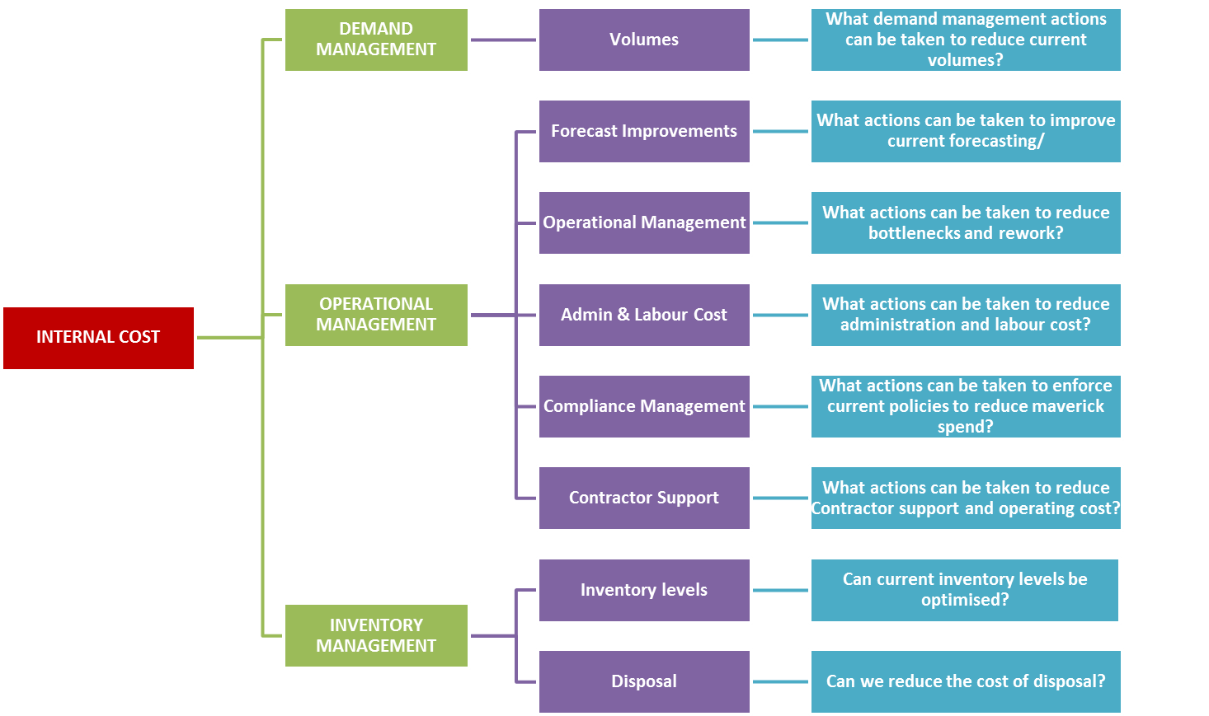

Options to reduce Joint Costs
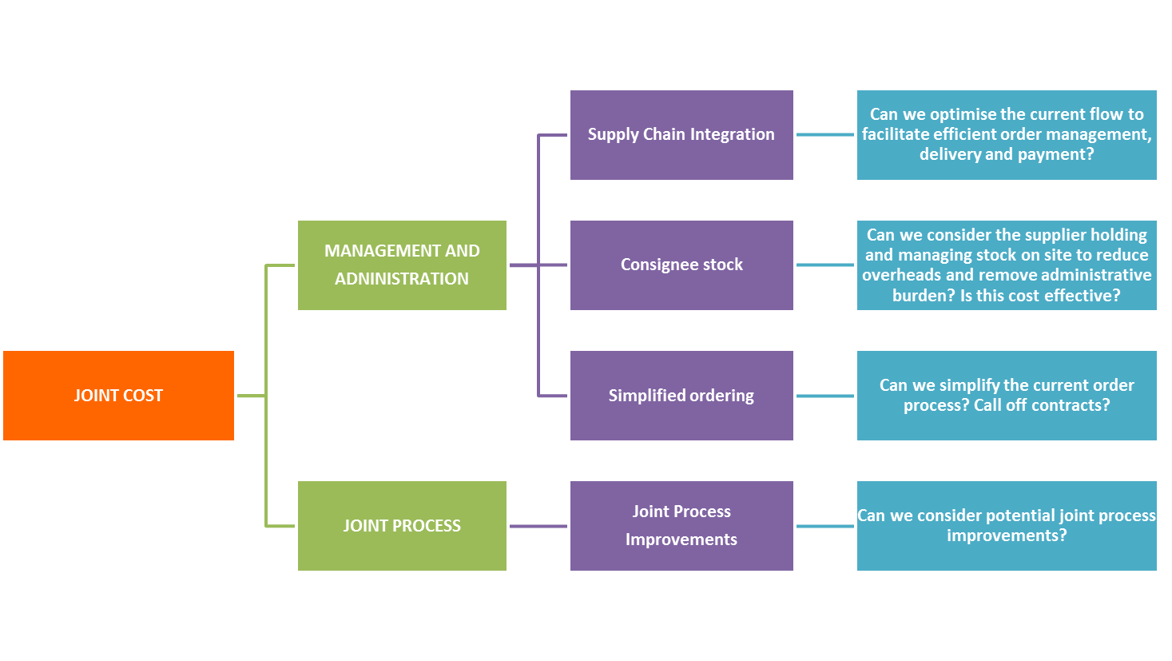

Grouping Ideas and Development of the Issue Tree
From the brainstorming session and the use of the issue trees discussed above, ideas should be grouped together in logical and coherent themes for further analysis as follows. The diagram below is an example of an Issue Tree for Mobile Communication identifying potential opportunities.
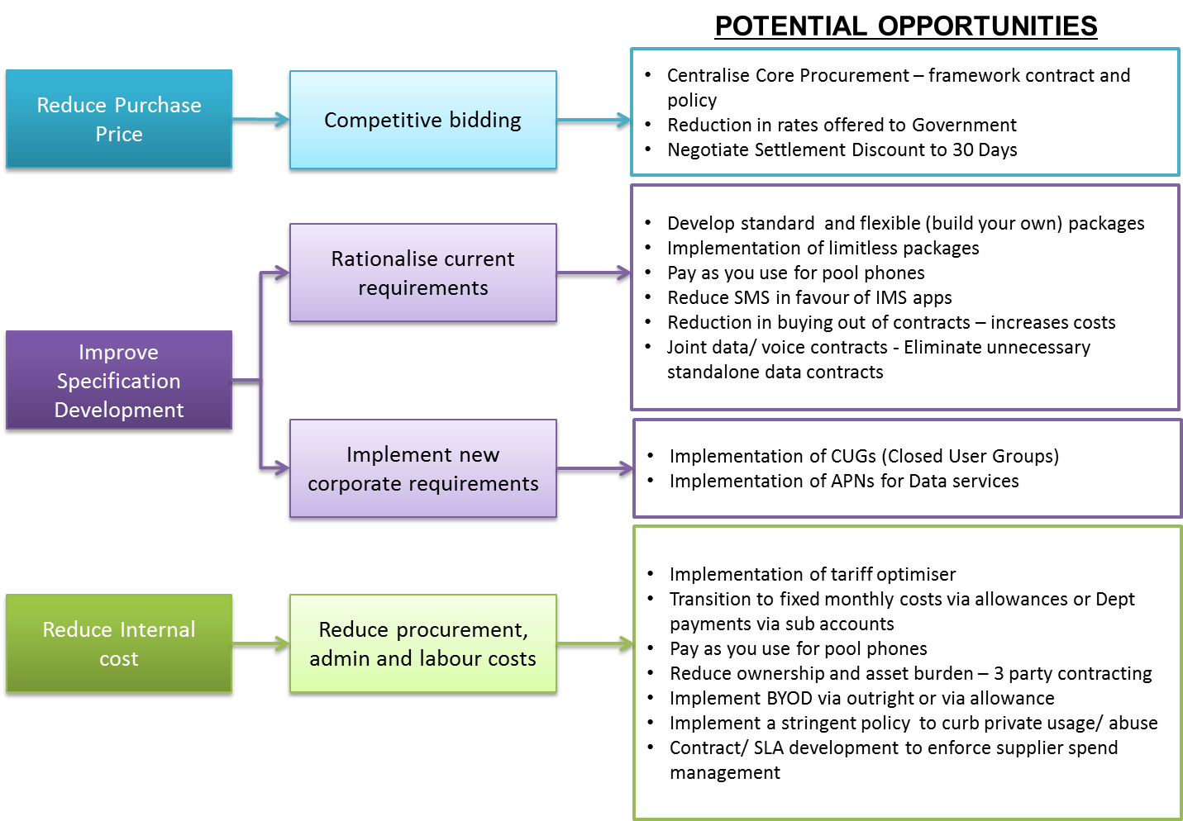

Evaluate and Quantify Ideas

Take each potential opportunity and let the CFST evaluate each one. Create a savings hypothesis for each opportunityas follows that can be tested later on.
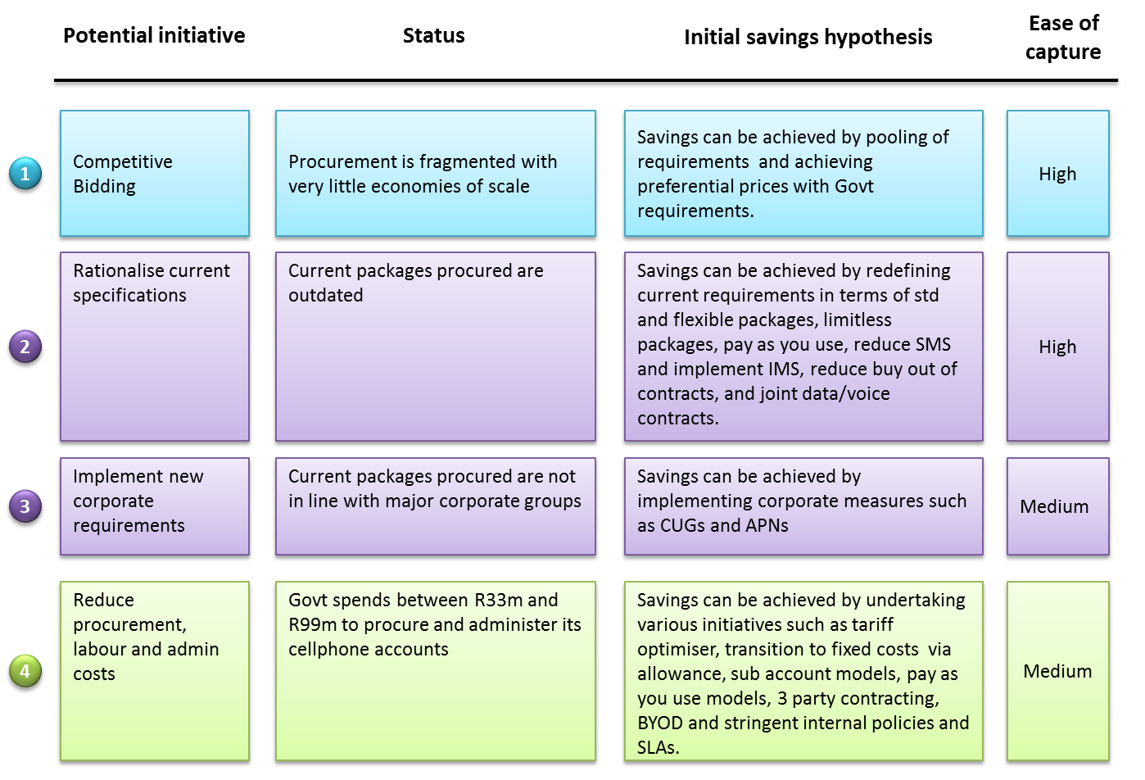

Ideas should further be evaluated in terms of the “Ease of implementation” and potential “Savings value”. Plot each idea on the Prioritisation Matrix as illustrated below. The ideas can then be prioritized in the following manner:
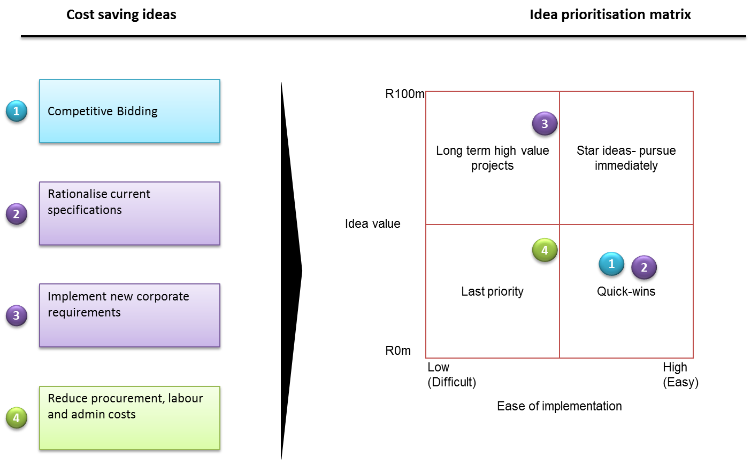
Priority 1 – Quick WIns: Ideas that fall within the “Quick Win” quadrant will be the easiest to implement, but may not result in substantial savings. These ideas will, however, set the momentum in motion.
Priority 2 – Star Ideas: Ideas that fall within the “Star Idea” quadrant will be easy to implement and will generate substantial savings opportunities.
Priority 3 – Long term/High Value Ideas: Ideas that fall within this quadrant will be more difficult to implement but will generate substantial savings opportunities if correctly managed.
Priority 4– Last Priority Ideas: Ideas that fall within this quadrant that will be the most difficult to implement and may take longer to implement. These ideas are often projects
on their own, but if correctly managed will
generate substantial savings.

INDUSTRY TRANSFORMATION
As part of the opportunities identification stage, focus should be paid to the government’s industry transformation goals as part of the five pillars of procurement. Alignment to the government policies which are designed to advance persons or categories of persons disadvantaged by unfair discrimination should be taken into account.
Industry transformation is vital to public sector procurement in South Africa. It ensures that government is committed to economic growth by implementing measures to support industry generally, and especially to advance the development of Small, Medium and Micro Enterprises, Historically Disadvantaged Individuals and Broad Based Black Economic Empowerment.
Greater participation in the economy and more diversified representation of blacks and gender in ownership is essential.
The government has implemented the Preferential Procurement Policy Framework Act (PPPFA) as the foundation on which all procurement activities are to be based. Its aim is to:
- Advance the development of SMMEs and BBBEE;
- Promote women and physically handicapped people;
- Create new jobs;
- Promote local enterprises in specific provinces, in a particular region, in a specific local authority, or in rural areas; and
- Support the local product.
In addition to documenting opportunities for industry transformation as part of the sourcing strategy the Sourcing Team must also ensure that the cost of bidding for opportunities does not deter SMMEs and limit BBBEE.

ANNEXURE 1

BRAINSTORMING SESSION TIPS
Location matters: Find a comfortable quiet room. If you can, pick a space not used by your team for any other purpose. If you use the same room that you use for boring status meetings, don’t expect people to be stimulated by the surroundings. Make sure there are big visible materials for writing on (whiteboards, or overhead projector), and a big chunk of time (at least an hour, preferably).
Have a specific purpose: The leader of the meeting should arrive with a specific question he’s trying to answer or problem to explore. It should be made clear to the group what it is, and the group should be provided with as much supporting information as they need. Match the purpose to the knowledge and background people might need: otherwise you’ll spend your brainstorm meeting lecturing people on the basics.
Know what you want, and what to do with it: If you are looking for a big raw list of news ideas to review later, then have a plan for how you’ll review it. The simplest strategy is to plan an hour afterwards, for yourself alone, to pull out the 5 or 10 most interesting ideas (based on your opinion, or the group’s) and examine them in detail. But also consider the people who attend: should that list of 5 or 10 things get sent out to them? Will you possibly assign those interesting ideas out to people to investigate further? Whatever your plan is, make it clear to the group before you start. There is nothing worse for a team to feel their creative thinking falling into a black hole. You’ll get better ideas and more energy from people if they can see where it’s all going to go. At a minimum, say you don’t know what happens next, but give them a deadline for when they’ll get an update from you. If you fail to do so, don’t expect people to be so creative at the next brainstorming session.
Know how to facilitate: Someone has to run the meeting, guiding the conversation in useful directions. Sometimes this can be the manager or lead person, but some managers don’t have the right skills or personality for it. Good facilitation requires good listening skills, very sharp group awareness, and the ability to help people express their ideas. The facilitator should run the whiteboard, writing down ideas as people come up with them, preventing people from interrupting each other, and giving the floor to quieter people who wouldn’t ordinarily find a way to contribute on their own. Often the facilitator has to minimize the number of their own contributions, in favour of just trying to help the group. Know who the best facilitator is and have them do it.
Put the focus on the list: The whiteboard or overhead projector should be the focal point of the meeting. Make it clear to everyone in the room that you are getting together with the goal of adding as many items as possible to that whiteboard. Good ideas are nice, but you are looking for raw quantity (if you take the time to sort out ideas too much, you’ll lose your creative momentum. You can evaluate ideas later) The person who runs the whiteboard should push the group to help each other rephrase or best describe any idea that is currently being discussed. This is another critical facilitation skill.
Comfort is key: Creative thinking involves exploring non-obvious and non-traditional ideas to find unexpected good ones. To find them you have to sort through many potential embarrassing, silly, goofy, or outrageous ideas. The catch is you can’t separate the good ones from the goofy ones until you’ve brought them out in the open and talked them through. The problem is that most people in the workplace are terrified of looking stupid in front of their peers or their superiors. They’ll only take that risk if they have great trust in the forum, the people in the room, or their manager. There are no tricks in achieving this, or to remedy it. Much of it starts with the leaders and facilitators to prove that it’s safe to have bad or goofy ideas, and rewarding others who are creatively courageous. However, if you have a group that isn’t comfortable being creative in front of each other, make the group smaller. Start with 2 or 3 people, or just let people work alone, and give their lists of ideas directly to you. Find the smallest nugget possible to start growing creative comfort on your team, reward it (even the seemingly outrageous ideas), and then slowly integrate that kind of comfort into larger group/team activities.
Establish the ground rules: This can help to establish comfort and make the time more useful. Will the meeting be a free for all, where anyone can suggest things at any time? Should people raise their hands? Who will write things down and document the proceedings? Is interrupting ok? Should people try to interpret and expand on each other’s ideas before yelling out another one of their own? Do what you can to reward team play: brainstorming should be about communicating, not competing.
Postpone criticism: This is the creativity killer. Evaluating ideas too much kills new ideas. Our minds shut down in a way if too much analysis goes on. A little bit is ok, but as soon as people start making implementation diagrams or talking about object models, it’s gone too far. Move on to the next idea. Keep it moving, and postpone evaluation till later. The only exception is questions people ask to help them understand and improve on the initial idea, or to take the idea in a different direction. It’s up to the facilitator to hold people to this, and to keep the meeting moving in a positive creative direction.

